13/11/2024
DSA PRACTICE DAY 4
- 1. Kth Smallest Number:
Given an array arr[] and an integer k where k is smaller than the size of the array, the task is to find the kth smallest element in the given array.
Note: Don't solve it using the inbuilt sort function.
Input: arr[] = [7, 10, 4, 3, 20, 15], k = 3
Output: 7
PROGRAM:
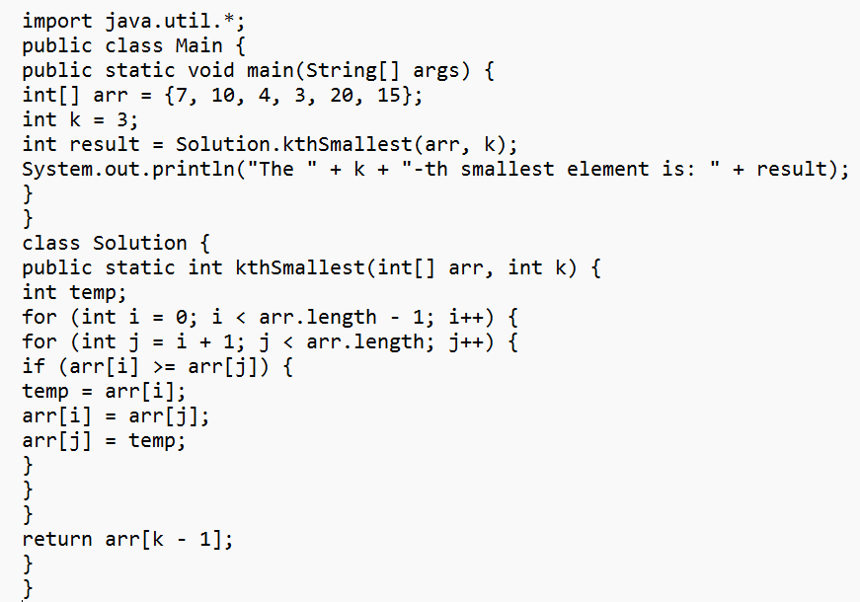
OUTPUT:
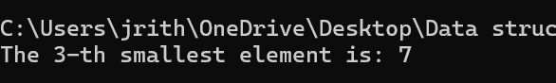
TIME COMPLEXITY: O(n^2)

- MINIMIZE THE HEIGHT 2’S:
PROGRAM:
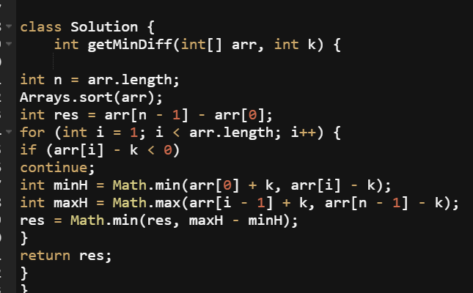
OUTPUT:
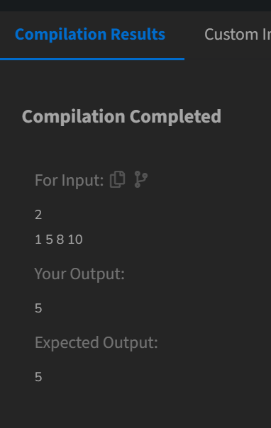
TIME COMPLEXITY: O(nlogn)

- PARENTHESIS CHECKER:
PROGRAM:
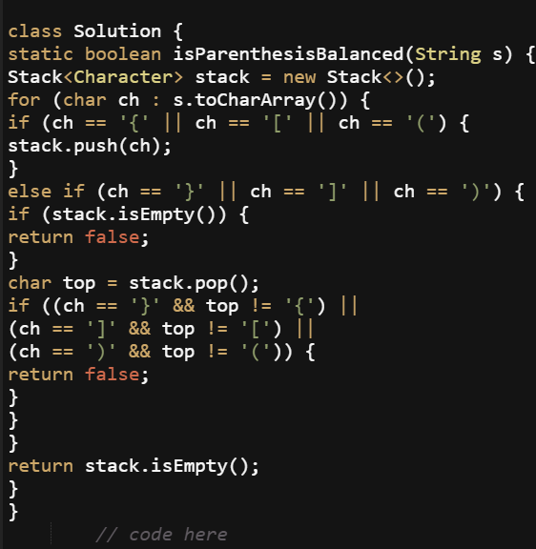
OUTPUT:
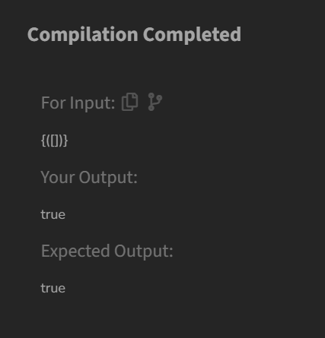
TIME COMPLEXITY: O(N)

- EQUILIBRIUM POINT:
PROGRAM:
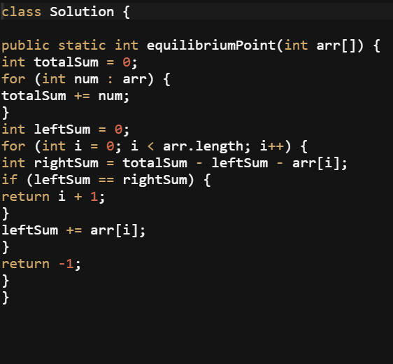

OUTPUT:
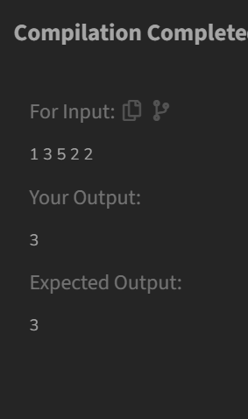
TIME COMPLEXITY: O(n)

- BINARY SEARCH:
PROGRAM:
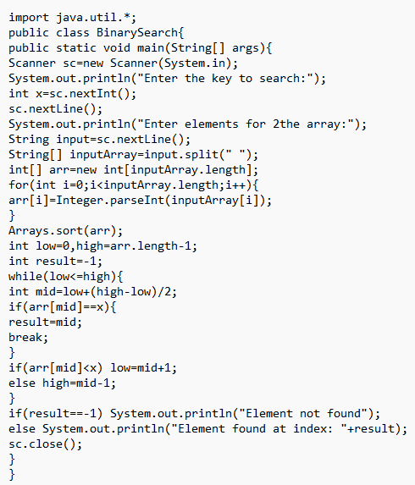
OUTPUT:
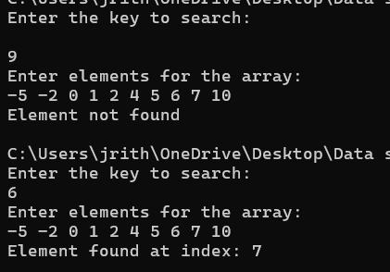
TIME COMPLEXITY: O (log n)

- NEXT GREATER ELEMENT:
PROGRAM:
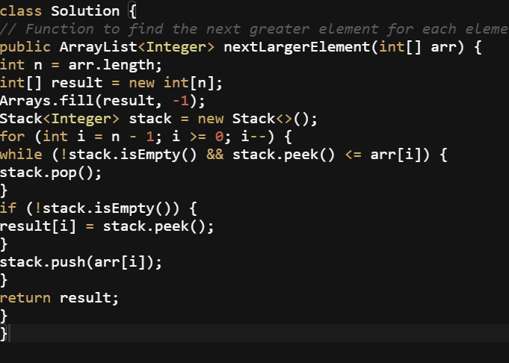
OUTPUT:
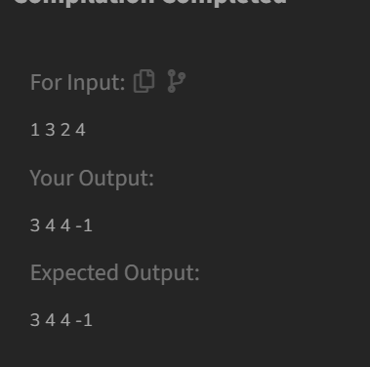
TIME COMPLEXITY:O(N)

- UNION OF TWO ARRAYS:
PROGRAM:
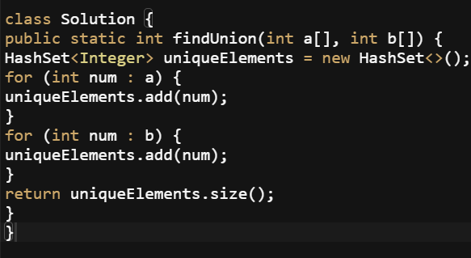
OUTPUT:
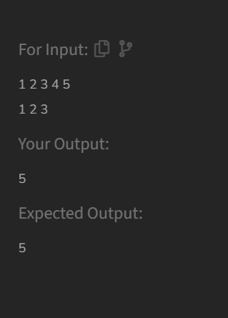

TIME COMPLEXITY: O(m+n)

